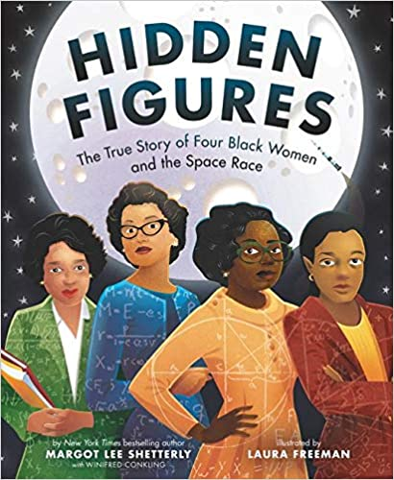
Catcott Primary School Medium Term Planning Year 5
Quality Text(s) | Hidden Figures- Memoire
Model Text
Pre-assessment writing task | Write a memoire of your life- choose one big event that stands out to write about.
Launch activity | Welcome to the NASA induction program:  As children arrive in the classroom, hand out lanyards and NASA/NACA identity badges (see resources). Ask children to go to their seats, write and sign their names on the badges and put on their lanyards. On the board have NASA/NACA Recruits Induction Program written and explain the they have joined the NASA/NACA induction program. Display both logos. Ask the following: What is different about the badges? What do you know about NASA/NACA? Do you know what the abbreviations stand for? Do you know any other abbreviations? What do you think you know about NASA/NACA? Are there any questions that you would like to find out?
Reading – comprehension and vocabulary focus | Apply their growing knowledge of root words, prefixes and suffixes (morphology and etymology),  as listed in English Appendix 1, both to read aloud and to understand the meaning of new words  that they meet  • Making comparisons within and across books  • Reading books that are structured in different ways and reading for a range of purposes  • Increasing their familiarity with a wide range of books, including myths, legends and traditional  stories, modern fiction, fiction from our literary heritage, and books from other cultures and traditions  Identifying and discussing themes and conventions in and across a wide range of writing  • Checking that the book makes sense to them, discussing their understanding and exploring the  meaning of words in context  • Drawing inferences such as inferring characters’ feelings, thoughts and motives from their actions,  and justifying inferences with evidence  • Predicting what might happen from details stated and implied  • Summarising the main ideas drawn from more than one paragraph, identifying key details that  support the main ideas  • Discuss and evaluate how authors use language, including figurative language, considering the  impact on the reader  • Provide reasoned justifications
Key text type features | • Relative clauses beginning with who, which, where, when, whose, that, or an omitted relative  pronoun  • Indicating degrees of possibility using adverbs [for example, perhaps, surely] or modal verbs [for  example, might, should, will, must]  • Linking ideas across paragraphs using adverbials of time [for example, later], place [for example,  nearby] and number [for example, secondly] or tense choices [for example, he had seen her before]  • Brackets, dashes or commas to indicate parenthesis  • Use of commas to clarify meaning or avoid ambiguity  • Use of expanded noun phrases to convey complicated information concisely  • Devices to build cohesion within a paragraph [for example, then, after that, this, firstly]  • How words are related by meaning as synonyms and antonyms [for example, big, large, little]  •
Focus language from text
Focus grammar and punctuation objectives | Alan Pete- 3 BAD- question. The more, the more. If, if,if, then. Inside (Outside) Some; others.
Writing task(s)  Individual?  Pair?  Group? | Shared: The Memoirs of Dorothy Vaughan and Mary Jackson.  The Memoirs of Dorothy Vaughan  Memoir of Katherine Johnson- link to Counting on Katherine
Editing Focus

