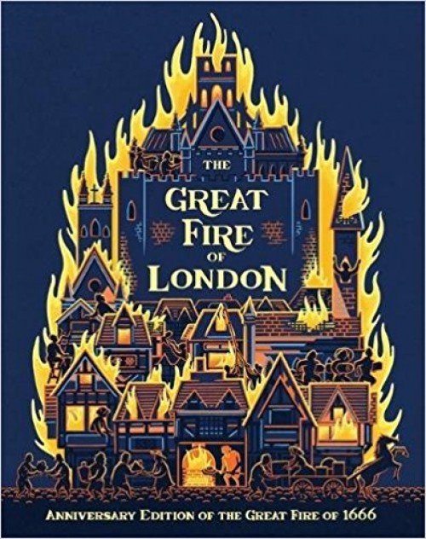
Catcott Primary School Medium Term Planning Year 2

Quality Text(s) | The Great Fire of London by Emma Adams and James Weston Lewis
Cross curricular links | History/ Geography
Pre-assessment writing task | Non Chronological Report about...something they will know about.
Audience and Purpose for Writing | A mini museum set up in classroom to teach others about the fire of London.
Model Text | https://grammarsaurus.co.uk/portal/2021/02/year-2-model-text-non-chronological-report-fire-safety-%f0%9f%8f%b4%f3%a0%81%a7%f3%a0%81%a2%f3%a0%81%b3%f3%a0%81%a3%f3%a0%81%b4%f3%a0%81%bf-p2-%f0%9f%87%a6%f0%9f%87%ba/
Reading – comprehension and vocabulary focus | Develop pleasure in reading, motivation to read, vocabulary and understanding by: • Discussing the sequence of events in books and how items of information are related • Discussing and clarifying the meanings of words, linking new meanings to known vocabulary • Being introduced to non-fiction books that are structured in different ways Understand both the books that they can already read accurately and fluently and those that they listen to by: • Drawing on what they already know or on background information and vocabulary provided by the teacher • Making inferences on the basis of what is being said and done • Predicting what might happen on the basis of what has been read so far • Explain and discuss their understanding of books, poems and other material, both those that they listen to and those that they read for themselves
Key text type features | Grammar: commands, subordinating conjunctions, co-ordinating conjunctions, subheadings, present progressive (if not historical), comparative and superlative  Punctuation: commas for a list, apostrophes for possession (GDS), question marks
Writing task(s)  Individual?  Pair?  Group? | Shared write: Non Chronological Report about The Great Fire of London (one on Grammarsaurus will guide you)  Hot task: Non Chronological Report about London- research together. Where is London? What should you visit in London? (Geography link)

