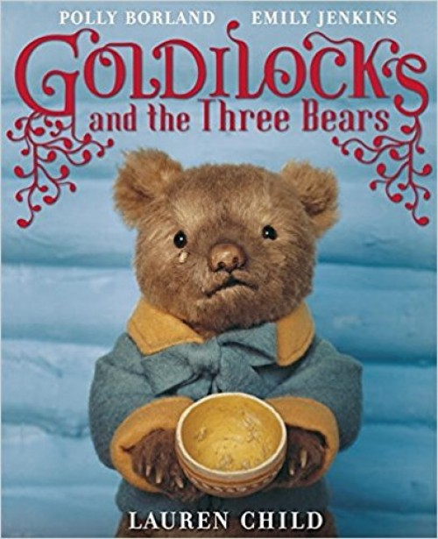
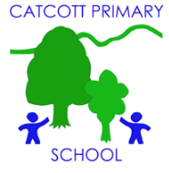Catcott Primary School Medium Term Planning Year 2

Quality Text(s) | Goldilocks and the Three Bears by Lauren Child
Pre-assessment writing task | Read them Cinderella- children write their own version changing some of the details. E.g. Cinderfella
Audience and Purpose for Writing | Children arrive on the first day to find three bowls of porridge. One of which is eaten and two with mouthfuls taken. The question ‘who has been here?’ is posed. Use talking partners to discuss what the clues may tell them and see if they can draw out from stories that it would be Goldilocks.
Model Text | https://grammarsaurus.co.uk/portal/2021/03/year-2-model-text-narrative-the-sleeping-prince-a-twisted-tale-%f0%9f%8f%b4%f3%a0%81%a7%f3%a0%81%a2%f3%a0%81%b3%f3%a0%81%a3%f3%a0%81%b4%f3%a0%81%bf-p2-%f0%9f%87%a6%f0%9f%87%ba%f0%9f%87%ba/
Reading – comprehension and vocabulary focus | Develop pleasure in reading, motivation to read, vocabulary and understanding by: • Listening to, discussing and expressing views about a wide range of contemporary and classic poetry, stories and non-fiction at a level beyond that at which they can read independently • Being encouraged to link what they read or hear read to their own experiences (Y1) • Becoming increasingly familiar with and retelling a wider range of stories, fairy stories and traditional tales Understand both the books that they can already read accurately and fluently and those that they listen to by: • Drawing on what they already know or on background information and vocabulary provided by the teacher • Making inferences on the basis of what is being said and done • Answering and asking questions
Key text type features | Grammar: rhetorical questions, adverbials of place, co-ordinating conjunctions, expanded noun phrases, expanded noun phrases, adverbials of place, adverbials of manner (including similes), co-ordinating conjunctions, subordinating conjunctions  Punctuation: question mark, commas in lists
Writing task(s)  Individual?  Pair?  Group? | Shared write: Goldilocks and the little Bear  Hot task: Read various versions of Little Red Riding Hood. Children create their own twisted version.

