Catcott Primary School Medium Term Planning Year 2 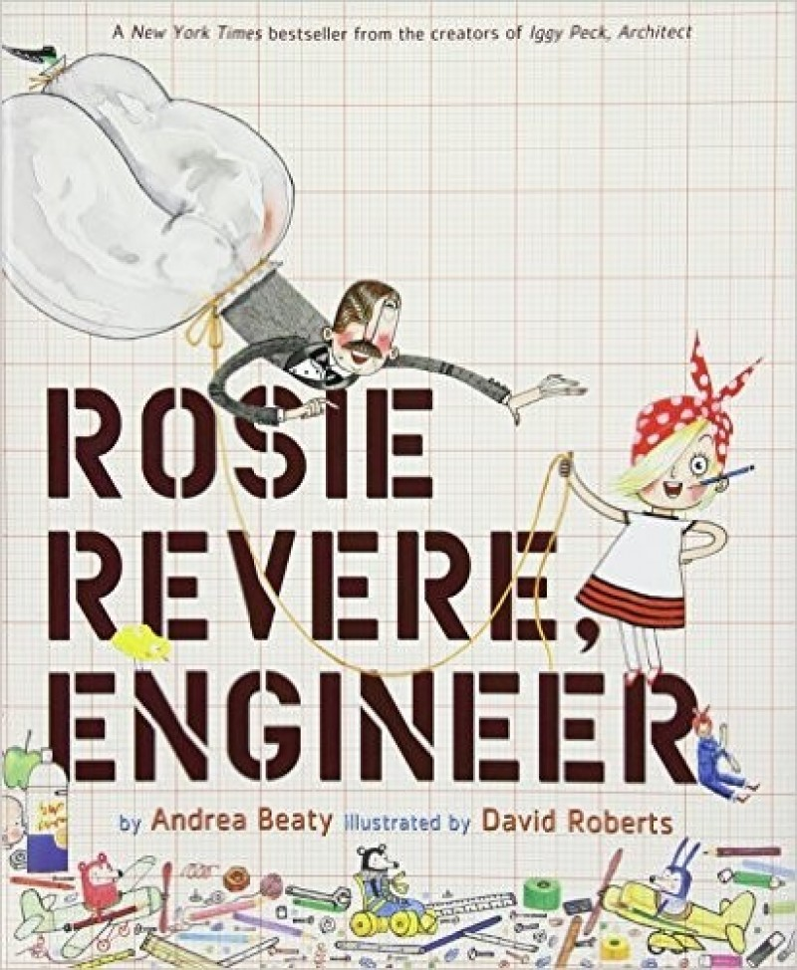

Quality Text(s) | Rosie Revere Engineer
Cross curricular links | Brunel
Pre-assessment writing task | Launch: Begin by designing their own suspension/ draw-bridges, then write a short explanation about how their bridge works. These designs are sent off as competition entries. Disappointingly, the children discover that they haven’t won the competition and that, in fact, a man called Horace Jones won.  Cold task: Explanation text of how their bridges work.
Model Text | https://grammarsaurus.co.uk/portal/2021/01/year-2-model-text-explanation-life-cycle-of-a-butterfly-%f0%9f%8f%b4%f3%a0%81%a7%f3%a0%81%a2%f3%a0%81%b3%f3%a0%81%a3%f3%a0%81%b4%f3%a0%81%bf-p2-%f0%9f%87%a6%f0%9f%87%ba-2/
Reading – comprehension and vocabulary focus | Listening to and discussing a wide range of poems, stories and non-fiction at a level beyond that at which they can read independently - Being encouraged to link what they read or hear read to their own experiences - Discussing word meanings, linking new meanings to those already known - Being introduced to non-fiction books that are structured in different ways - Drawing on what they already know or on background information and vocabulary provided by the teacher
Key text type features | Grammar: subordinating conjunctions, adverbials of time, adverbials of place, rhetorical questions, adverbials of time, adverbs of manner, apostrophes for possession (GDS), expanded noun phrases, co-ordinating conjunctions, statements  Punctuation: question marks, commas for lists
Writing task(s)  Individual?  Pair?  Group? | Shared: receive a letter from Rosie asking for help with writing a series of leaflets about engineering of famous landmarks. She knows that they are visiting The Suspension Bridge – can they research this landmark and write a leaflet? Research, plan and share write a non chronological report about it, exploring how the machinery in the engine room functions. They could then write up in neat in the form of a leaflet.  Hot task: Research another of Brunel’s inventions to create their own non chronological report about.

