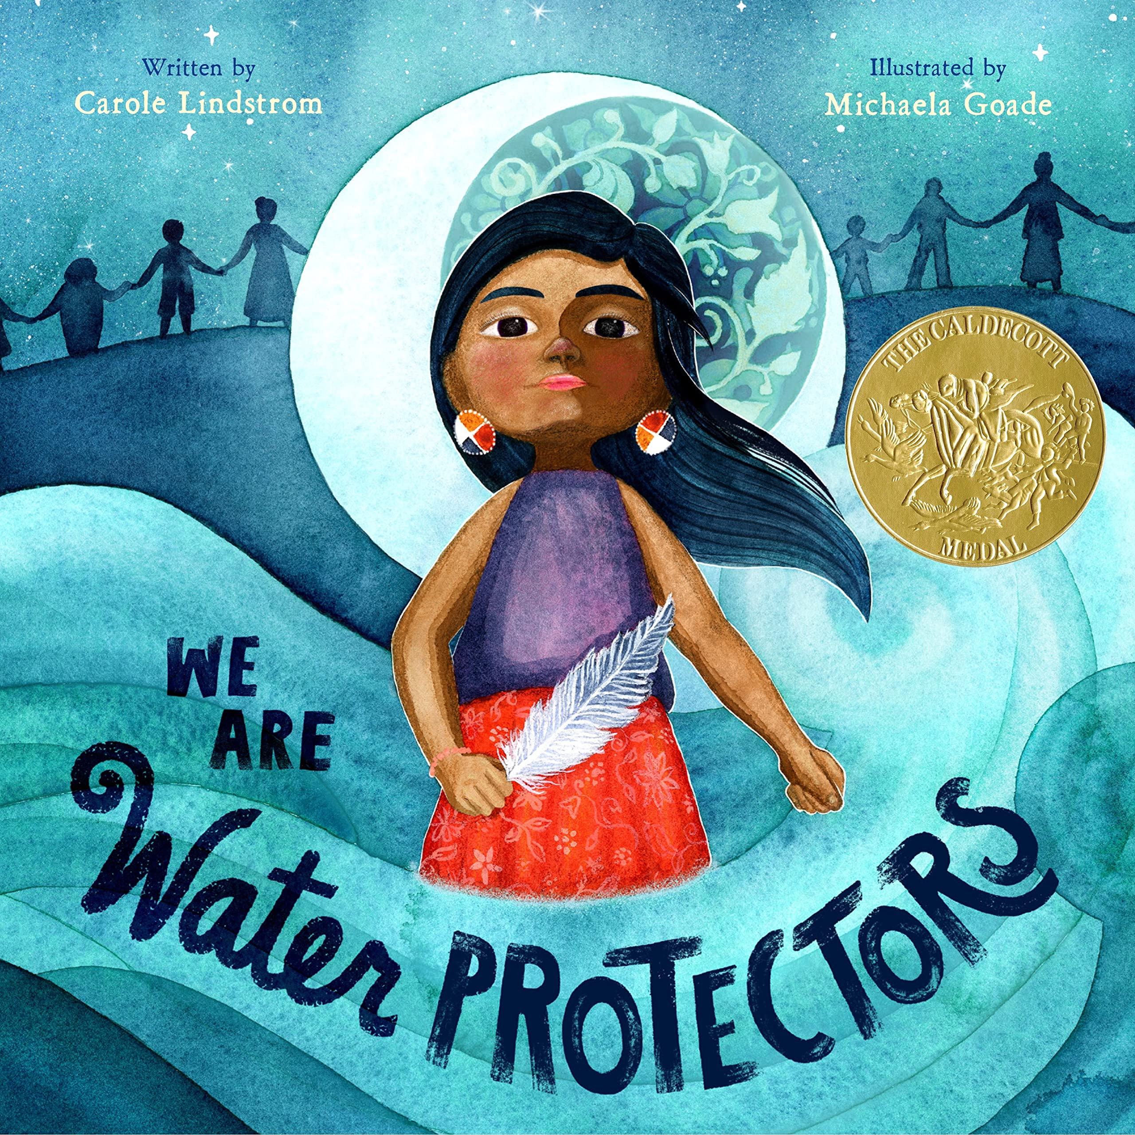
Catcott Primary School Medium Term Planning Year 2

Quality Text(s) | We Are Water Protectors
Cross curricular links | History/ Geography
Pre-assessment writing task | Persuasive text- try to link to protecting something- maybe watch a David Attenbourgh clip.
Audience and Purpose for Writing | Assembly linking to eco club- maybe links to applying for eco school award?
Model Text | Save the Polar Bears  https://grammarsaurus.co.uk/portal/2022/11/year-2-model-text-persuasive-advert-save-the-polar-bears-%f0%9f%8f%b4%f3%a0%81%a7%f3%a0%81%a2%f3%a0%81%b3%f3%a0%81%a3%f3%a0%81%b4%f3%a0%81%bf-p2-%f0%9f%87%a6%f0%9f%87%ba/
Reading – comprehension and vocabulary focus | Develop pleasure in reading, motivation to read, vocabulary and understanding by: • Listening to, discussing and expressing views about a wide range of contemporary and classic poetry, stories and non-fiction at a level beyond that at which they can read independently • Recognising simple recurring literary language in stories and poetry • Discussing and clarifying the meanings of words, linking new meanings to known vocabulary Understand both the books they can already read accurately and fluently and those they listen to by: • Answering and asking questions  Continue to apply phonic knowledge and skills as the route to decode words until automatic decoding has become embedded and reading is fluent • Read accurately by blending the sounds in words that contain the graphemes taught so far, especially recognising alternative sounds for graphemes • Read accurately words of two or more syllables that contain the same graphemes as above • Read words containing common suffixes
Key text type features | Grammar: rhetorical questions, list of three, subordinating conjunctions, co-ordinating conjunctions, expanded noun phrases, facts and statistics. Commands, opinions (can be expert), exaggerated language, emotive language (if applicable), deals and bargains (if applicable)  Punctuation: commas in a list, quotation marks, exclamation marks
Writing task(s)  Individual?  Pair?  Group? | Shared write: Persuasive leaflet- protect the local nature reserve (school visit?)  Hot task: Research/ link to another environmental cause e.g. recycle plastic…

