Catcott Primary School Medium Term Planning Year 3 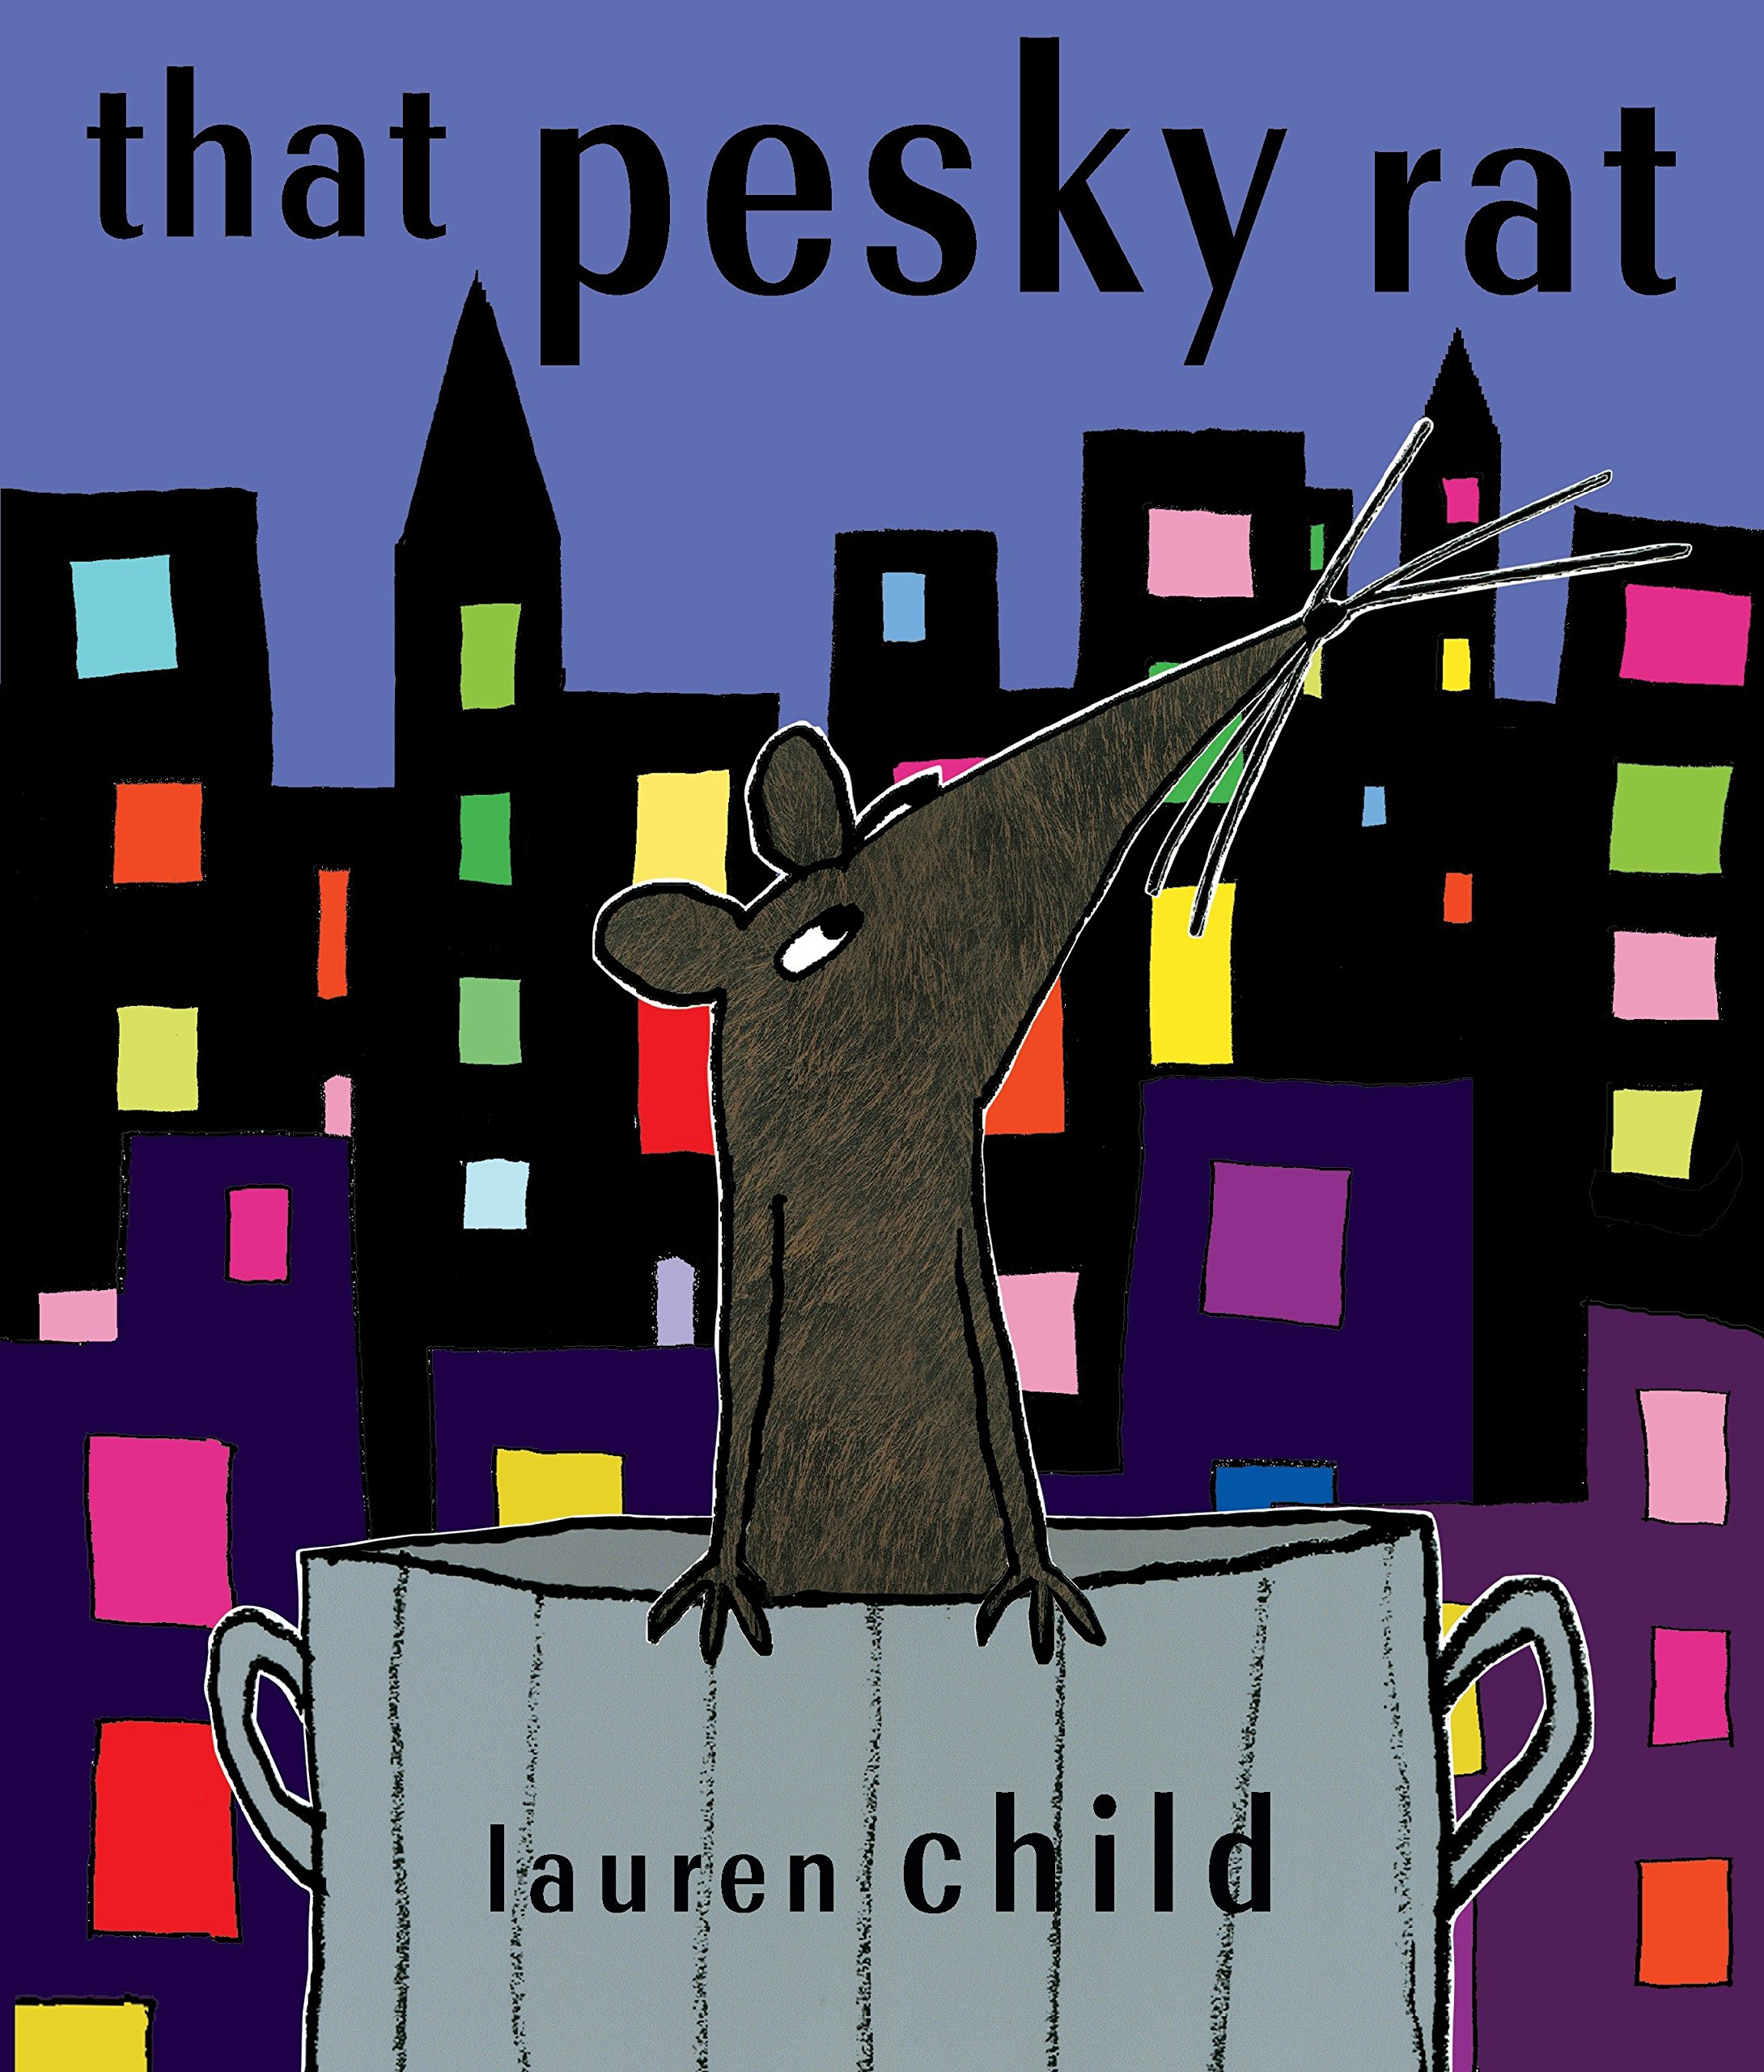
Quality Text(s) | ‘That Pesky Rat’ by Lauren Child. Cinderella stories link including Yen Shen.
Model Text | https://grammarsaurus.co.uk/portal/2020/07/year-3-model-text-character-tinker-bell/
Pre Assessment Cold Task | Previous to starting That Pesky Rat, spend a week studying different Cinderella style stories including Yen Shen as a Chinese link. Look at similarities and differences between the different versions.  Read Children Yeh Shen and they write a character description of her.
Audience and Purpose for Writing | Write to Lauren Child and share the outcomes from the focus on the book (c/o David Higham Associates www.davidhigham.co.uk )
Launch activity | Place a toy rat (IKEA) in a crisp packet in a bin with a number 3 on the side in your classroom.
Reading – comprehension and vocabulary focus | Check understanding of vocabulary: pesky – cosy – chinchilla – glamorous - fashionable apartment - pet parlour – trapeze – tutu – popular - squint  Discuss handwriting/paw writing  Rags to Riches story  Discuss how the rat feels at the beginning and at end of the book  Is it right that the rat and Mrs Trill (pet shop owner) deceive Mr Fortesque?
Key text type features | Grammar: rhetorical questions, adverbials of place, adverbials of time, expanded noun phrases, co-ordinating conjunctions, participial phrases, participial adjectives, expanded noun phrases, adverbials of place, adverbials of manner (including similes), subordinating conjunctions, short sentences for e­ect, rhetorical questions, relative clauses (Y4)  Punctuation: commas for fronted adverbials (Y4), question marks
Focus language from text | Check understanding of: creature comforts - lap of luxury - putting my feet up - nerve wracking - good company - neither of us said a word
Writing task(s)  Individual?  Pair?  Group? | In groups: collaborative writing: write notices for each of the animals waiting to be chosen in the pet shop: rats – cats – bird – snake – turtle – fish – mice – reptile – stick insects – rabbits – dogs  Shared writing:  Write character descriptions of the different characters in Pesky Rat  Hot task- to plan their own character for their own rags to riches style story and write a character description of their main character.
Editing Focus | Subordination  Paragraphs – cohesion

