Catcott Primary School Medium Term Planning Year 3 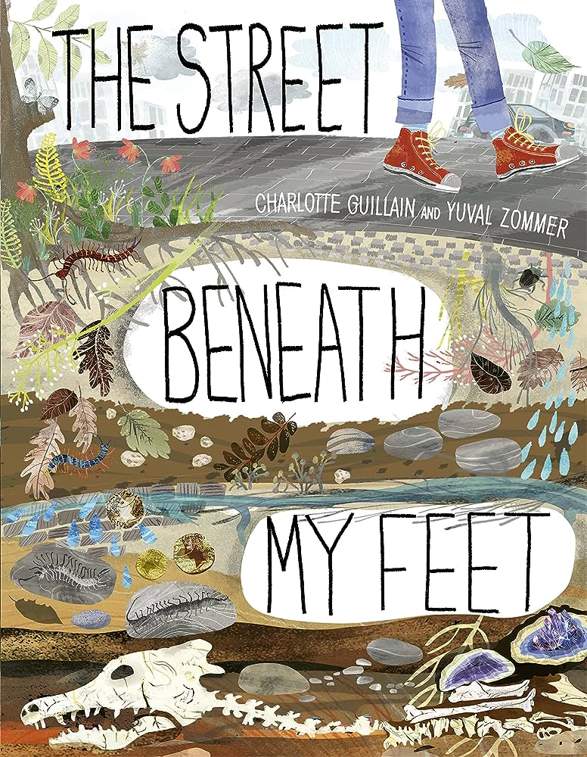
Quality Text(s) | The Street Beneath my Feet
Cross curricular links | Science: Rocks and Soils
Model Text | https://grammarsaurus.co.uk/portal/2022/12/year-3-model-text-explanation-how-are-fossils-formed-%f0%9f%8f%b4%f3%a0%81%a7%f3%a0%81%a2%f3%a0%81%b3%f3%a0%81%a3%f3%a0%81%b4%f3%a0%81%bf-p3-%f0%9f%87%a6%f0%9f%87%ba%f0%9f%87%ba/
Pre-assessment writing task | Cold task: How can you keep your Wolley Mammoth Clean? Link to wash a wolley mammoth.
Launch activity? | Front cover predictions.
Reading – comprehension focus  (from ‘at a glance ‘grid) | To understand what they read, in books they can read independently, by:  ~ checking that the text makes sense to them, discussing their understanding and explaining the meaning of words in context  ~ asking questions to improve their understanding of a text  ~ identifying main ideas drawn from more than one paragraph and summarising these  ~ identifying how language, structure, and presentation contribute to meaning  ~ retrieve and record information from non-fiction.
Key text type features | Grammar: subordinating conjunctions, adverbials of time, adverbials of place, rhetorical questions, adverbs of time, adverbs of manner, apostrophes for possession, expanded noun phrases, coordinating conjunctions  Punctuation: commas for fronted adverbials (Y4), commas for clauses (Y4), commas for lists, question marks
Writing task(s)  Individual?  Pair?  Group? | Share write: Explanation text: What is beneath our feet?  Introduction, living things in top soil, historical artefacts, rock layers, layers of the earth, caves, concluding paragraph.  Hot task: How was fire made in the Stone Age? History Link. Research together.
Editing Focus | • proof-read for spelling and punctuation errors

