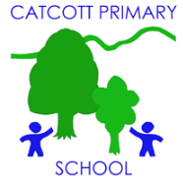Catcott Primary School Medium Term Planning Year 3 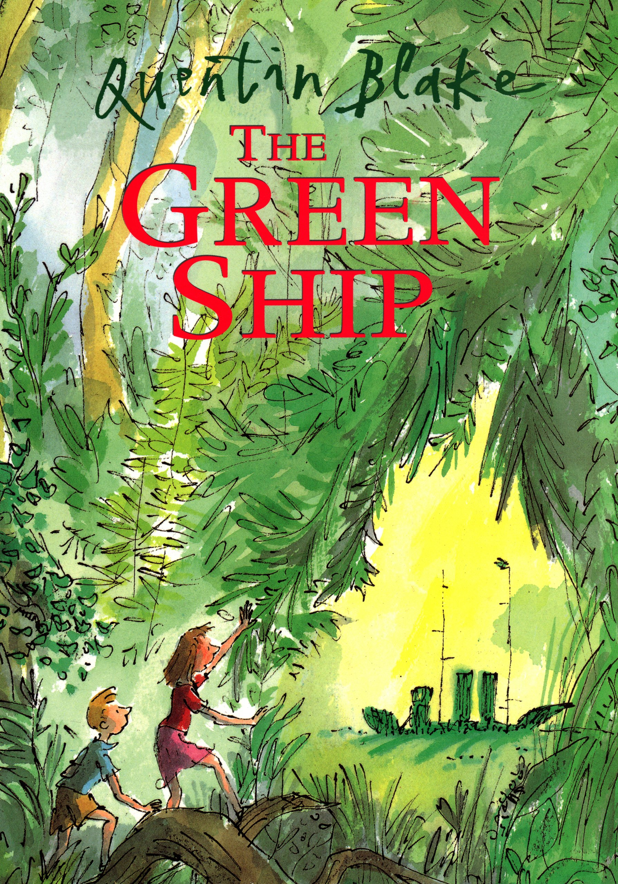
Quality Text(s) | “The Green Ship” by Quentin Blake
Model Text | https://grammarsaurus.co.uk/portal/2022/02/year-3-model-text-setting-description-enchanted-woodland-%f0%9f%8f%b4%f3%a0%81%a7%f3%a0%81%a2%f3%a0%81%b3%f3%a0%81%a3%f3%a0%81%b4%f3%a0%81%bf-p3-%f0%9f%87%a6%f0%9f%87%ba%f0%9f%87%ba/
Pre-assessment writing task | Setting description using a picture stimulus.
Audience and Purpose for Writing | Class book to share with other classes.
Launch activity | Take the children to an outdoor space (park, garden, forest school area) and read the story aloud. What do the plants and trees in this setting remind us of? What could they be if we use our imagination? Ask have they ever played on model castles, forts, and steam trains in local parks? Where do they go in their imagination? Share with each other and describe using as much descriptive language as possible. Draw & annotate something in the garden that could be used use to sail to another place. Write a few sentences to explain their journey. Share with a partner.
Reading – comprehension and vocabulary focus | Talk about the cover: (Note: the back and front covers create one image). Invite the children to discuss: Where do you think this story is set? What time of year do you think it is? How many characters can we see? Who you think they are? Do they know each other? What do you think they might be doing in this forest? What has just happened? Why do you think there is a Green Ship in the middle of the forest? Isn't that rather strange? What do you imagine will happen next? Where might they go? Story-map the text & learn as a class. Use same symbols for conjunctions, adverbs & prepositions.
Key text type features | Grammar: rhetorical questions, adverbials of place, adverbials of time, subordinating conjunctions, participial phrases, participial adjectives, expanded noun phrases, adverbials of place, adverbials of manner (including similes), co-ordinating conjunctions, rhetorical questions, short sentences for e­ffect, ellipses (Y4), short sentences for effect  Punctuation: commas for fronted adverbials (Y4), question marks
Focus language from text | Search for unusual vocab – especially nautical terms bow, stern, funnel, masts, and wheelhouse.  Look at how colours in the illustrations change to show the impending storm. Find prepositions to describe where objects are in relation to others. Collect & use on working wall. Find conjunctions & adverbs in text & display to use in own writing.
Writing task(s)  Individual?  Pair?  Group? | Immerse: Learn story by heart using story map. Re-tell as a class.  Shared write: Rewrite the beginning really focusing on the setting description.  Hot task: Write a setting description using a picture stimulus- children choose from a variety.
Editing Focus | Read aloud their own writing, using appropriate intonation and controlling the tone and volume so that the meaning is clear. Assess the effectiveness of their own and others’ writing and suggesting improvements with reference to a toolkit. Have they included description using prepositions, adverbs & conjunctions accurately?

