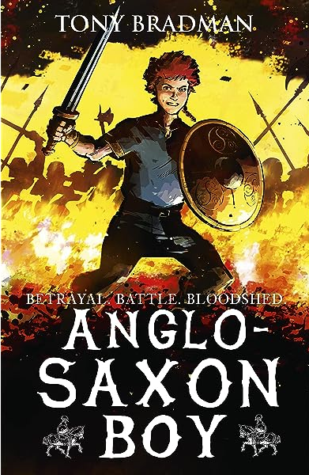
 Catcott Primary School Medium Term Planning Year 4
Quality Text(s) | Anglo Saxon Boy
Pree Assessment task | Cold task: write a diary entry based on…..
Model Text | https://grammarsaurus.co.uk/portal/2023/01/year-4-model-text-recount-diary-battle-with-boudicca-%f0%9f%8f%b4%f3%a0%81%a7%f3%a0%81%a2%f3%a0%81%b3%f3%a0%81%a3%f3%a0%81%b4%f3%a0%81%bf-p4-%f0%9f%87%a6%f0%9f%87%ba/
Launch activity

Reading – comprehension and vocabulary focus | • Identifying the audience for and purpose of the writing, selecting the appropriate form and using other similar writing as models for their own • In writing narratives, considering how authors have developed characters and settings in what pupils have read, listened to or seen performed • Selecting appropriate grammar and vocabulary, understanding how such choices can change and enhance meaning • In narratives, describing settings, characters and atmosphere and integrating dialogue to convey character and advance the action - Précising longer passages • Using a wide range of devices to build cohesion within and across paragraphs • Assessing the effectiveness of their own and others’ writing • Proposing changes to vocabulary, grammar and punctuation to enhance effects and clarify meaning
Key text type features | Grammar: date, salutation, past tense, chronological order, first person, facts and opinions, rhetorical questions, adverbials of time, adverbials of place, co-ordinating conjunctions, subordinating conjunctions, expanded noun phrases  Punctuation: commas for fronted adverbials (Y4), commas for clauses (Y4), apostrophes for omission, apostrophes for possession
Writing task(s)  Individual?  Pair?  Group? | Shared Write: Writing various diary entries in role as the central characters, as well as diary entries from the perspective of historical figures chronicling key historical events.  Hot task: Select a further event for children to write a diary entry about

