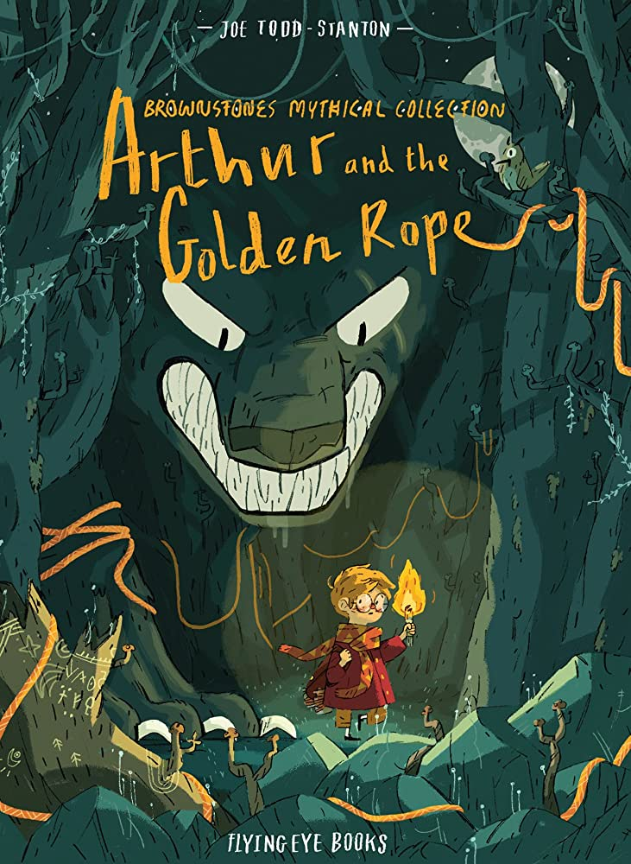
 Catcott Primary School Medium Term Planning Year 4
Quality Text(s) | Arthur and the Golden Rope
Pree Assessment task | Cold task: write a persuasive travel booklet for Italy
Model Text | https://grammarsaurus.co.uk/portal/2023/06/year-4-model-text-persuasive-leaflet-visit-incredible-india-%f0%9f%8f%b4%f3%a0%81%a7%f3%a0%81%a2%f3%a0%81%b3%f3%a0%81%a3%f3%a0%81%b4%f3%a0%81%bf-p4-%f0%9f%87%a6%f0%9f%87%ba/
Launch activity | Before starting work on the book, create a space in the classroom for a working wall to enable you to pin examples of responses, reflections, notes and language generated from each session. If you do not have the space for a working wall you could create a class ‘reading journal’ using large pieces of sugar paper and use the pages of the journal to capture responses. It would be highly beneficial to create a display, as part of your class reading environment, of related texts – fiction and non-fiction – that would allow children to read and research further stories of Norse Gods and Viking settlers. These texts might also form part of your read aloud programme in preparing for storytelling, retellings and in supporting the class in making connections with a wide range of material.
Reading – comprehension and vocabulary focus | Understand what they read by: ♣ checking that the book makes sense to them, discussing their understanding and exploring the meaning of words in context ♣ asking questions to improve their understanding ♣ drawing inferences such as inferring characters’ feelings, thoughts and motives from their actions, and justifying inferences with evidence ♣ predicting what might happen from details stated and implied ♣ identifying how language, structure and presentation contribute to meaning ♣ discuss and evaluate how authors use language, including figurative language, considering the impact on the reader ♣ participate in discussions about books that are read to them and those they can read for themselves, building on their own and others’ ideas and challenging views courteously
Key text type features | Grammar: rhetorical questions, list of three, subordinating conjunctions, co-ordinating conjunctions, expanded noun phrases, facts and statistics, opinions (can be expert), exaggerated language, emotive language (if applicable), deals and bargains (if applicable), commands  Punctuation: commas in a list, commas for fronted adverbials (Y4), commas for clauses (Y4), commas in a list, quotation marks, exclamation marks
Writing task(s)  Individual?  Pair?  Group? | Shared: Research and create a persuasive advert for Iceland.  Hot task: Research and create a persuasive advert for a different Norse Country

