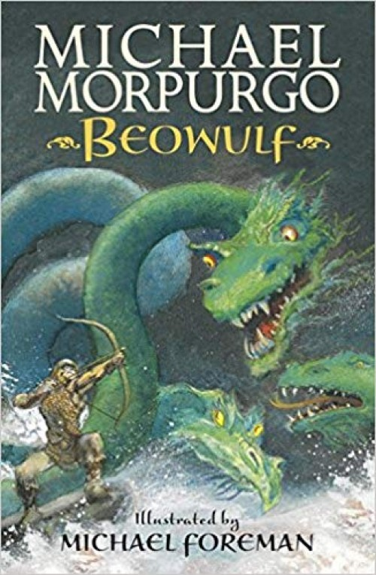
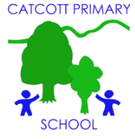 Catcott Primary School Medium Term Planning Year 4
Quality Text(s) | Beowulf
Pree Assessment task | Cold task: show various mythical creatures- children choose one to create a character description for
Model Text | https://grammarsaurus.co.uk/portal/2023/04/year-4-model-text-character-description-yeti-%f0%9f%8f%b4%f3%a0%81%a7%f3%a0%81%a2%f3%a0%81%b3%f3%a0%81%a3%f3%a0%81%b4%f3%a0%81%bf-p4-%f0%9f%87%a6%f0%9f%87%ba%f0%9f%87%ba/
Launch activity | Explain that today we are going to be archaeologists and that we are going to excavate the tomb/barrow of a famous Anglo-Saxon Warrior-King. Have trays full of sand with a number of Anglo-Saxon treasures buried in it (see resources) which the children will discover and identify (have these pictures laminated and use a brush to brush off the sand). Add more treasures which can be found online. Have also in one of the trays an epitaph with the inscription of the king who is buried here (see resources). Make this look old and crumpled. Also, include a picture of the original manuscript of Beowulf written in Old English which can also be found online. Who might this have been? What do you think the word ‘barrow’ means? What artefacts can you see? What could they have been used for? Why were famous, important people from ancient society often buried with treasure/possessions? Why were there no remains? Look up ‘Hronesness’ and see where this is?
Reading – comprehension and vocabulary focus | • Identifying the audience for and purpose of the writing, selecting the appropriate form and using other similar writing as models for their own • In writing narratives, considering how authors have developed characters and settings in what pupils have read, listened to or seen performed • Selecting appropriate grammar and vocabulary, understanding how such choices can change and enhance meaning • In narratives, describing settings, characters and atmosphere and integrating dialogue to convey character and advance the action - Précising longer passages • Using a wide range of devices to build cohesion within and across paragraphs • Assessing the effectiveness of their own and others’ writing • Proposing changes to vocabulary, grammar and punctuation to enhance effects and clarify meaning
Key text type features | Grammar: rhetorical questions, adverbials of place, adverbials of time, expanded noun phrases, co-ordinating conjunctions, participial phrases, participial adjectives, expanded noun phrases, adverbials of place, adverbials of manner (including similes), subordinating conjunctions, short sentences for eect, rhetorical questions, relative clauses (Y4)  Punctuation: commas for fronted adverbials (Y4), question marks
Writing task(s)  Individual?  Pair?  Group? | Shared write: Character description of Grendal and other monsters  Hot task: ‘Hear, and listen well, my friends, and I will tell you a tale…’ Remind children about the role of the bard in ancient cultures. Bards often sang songs, wrote poems or told stories. This was important in a time when many were illiterate. This created a rich oral tradition of poetic storytelling that exists even today. It is said that some bards could memorise hundreds of stories! Explain that we are going to be bards and either write their own ancient British legend or write a missing chapter for Beowulf (a new monster he had to fight). Children decide on their hero’s name and invent a monster that he/she has to fight (mention that in Anglo-Saxon/Viking culture woman-warriors were often referred to as Shield Maidens). Children write the chapter with a big focus on describing their character.

