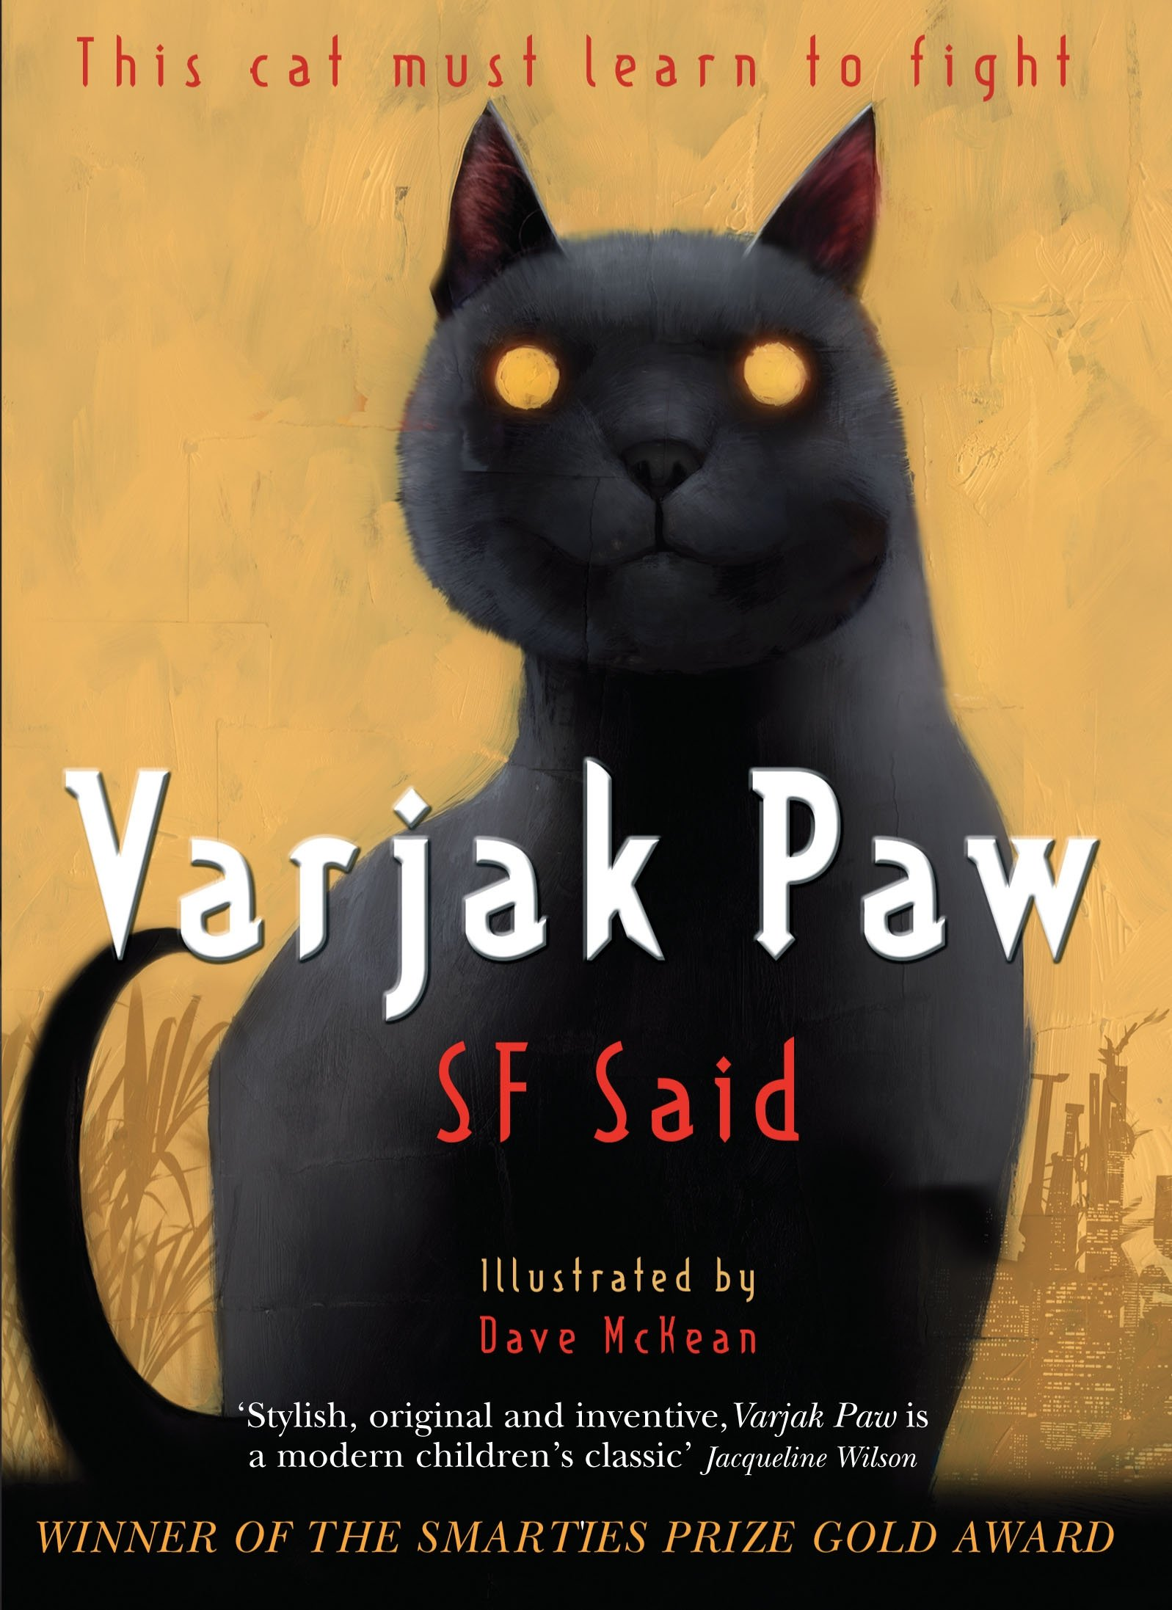
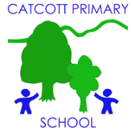 Catcott Primary School Medium Term Planning Year 4
Quality Text(s) | Varjak Paw
Pree Assessment task | Cold task: Read Pie Corbett’s ‘Haunted House. Children write their own adventure story.
Model Text | Haunted House
Launch activity | Missing cat poster displayed in the school. Hunt around school with black cats with key words from text written on them e.g. moving circles. Trail eventually leads to the book.
Reading – comprehension and vocabulary focus | Book talk- reading as a reader. How does the text make you feel? Identifying new vocab.  Reading as a writer- interaction between characters. Sentence structure, how has they created that effect?  Lots of inference. Show don’t tell references.
Key text type features | Grammar: rhetorical questions, adverbials of place, adverbials of time, subordinating conjunctions, participial phrases, participial adjectives, expanded noun phrases, adverbials of place, adverbials of manner (including similes), co-ordinating conjunctions, rhetorical questions, short sentences for e­ffect, ellipses (Y4), short sentences for effect  Punctuation: commas for fronted adverbials (Y4), question marks
Writing task(s)  Individual?  Pair?  Group? | Shared write: Re-write various chapters and extracts.  Hot task: Write your own ending chapter.
Editing Focus | Peer edit. Type up final stories to be used in class book.

