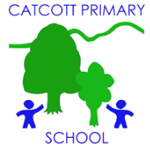 Catcott Primary School Medium Term Planning Year 4 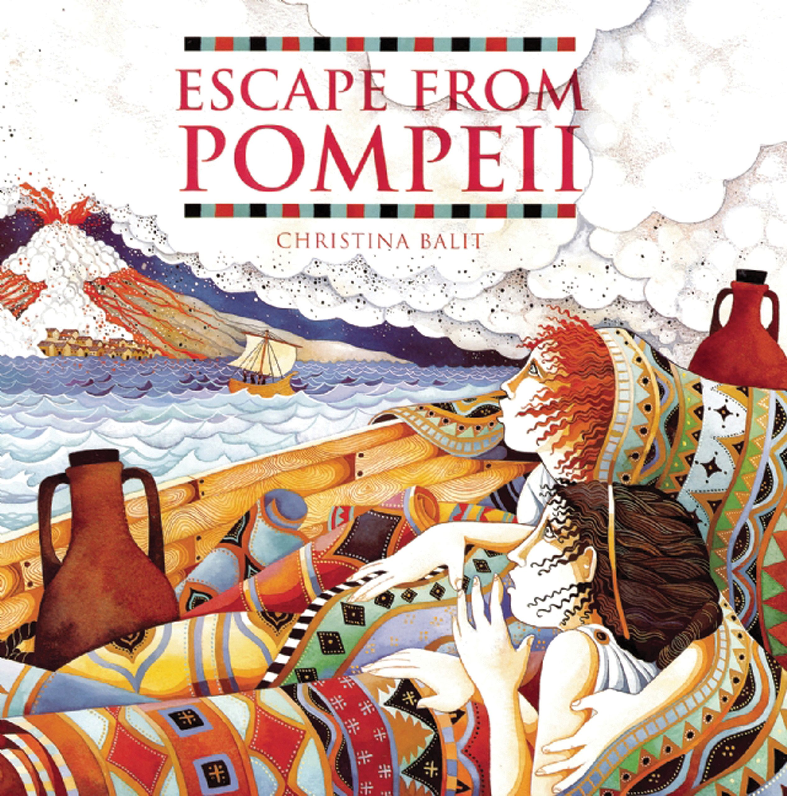
Quality Text(s) | Escape from Pompeii
Cross curricular links | Romans
Pre Assessment task | Cold task: Write a non-chronological report about volcanoes- following their geography topic from last term.
Launch activity | ODL- volcano activity and archaeology dig for items that may have been found in Pompeii.
Model Text | https://grammarsaurus.co.uk/portal/2022/07/year-4-model-text-non-chronological-report-volcanoes-%f0%9f%8f%b4%f3%a0%81%a7%f3%a0%81%a2%f3%a0%81%b3%f3%a0%81%a3%f3%a0%81%b4%f3%a0%81%bf-p4-%f0%9f%87%a6%f0%9f%87%ba%f0%9f%87%ba/
Reading – comprehension and vocabulary focus | • Listening to and discussing a wide range of fiction, poetry, plays, non-fiction and reference books or textbooks • Reading books that are structured in different ways and reading for a range of purposes • Increasing their familiarity with a wide range of books, including fairy stories, myths and legends, and retelling some of these orally • Discussing words and phrases that capture the reader’s interest and imagination • Asking questions to improve their understanding of a text • Drawing inferences such as inferring characters’ feelings, thoughts and motives from their actions, and justifying inferences with evidence • Predicting what might happen from details stated and implied • Participating in discussion about both books that are read to them and those they can read for themselves, taking turns and listening to what others say
Key text type features | Grammar: present perfect tense, subordinating conjunctions, co-ordinating conjunctions, expanded noun phrase, subheadings, tense switch (if applicable), rhetorical questions  Punctuation: commas for a list, apostrophes for possession, commas after fronted adverbials (Y4), commas for clauses (Y4), question marks
Writing task(s)  Individual?  Pair?  Group? | Shared write:  : Research and write a non chronological report about Vesuvius.  Research and write a non chronological report about Pompeii  Hot task: Research and write about the Romans. Given them choices of which part of Roman life they would like to write about- this could be very general or be specific e.g. Roman Sport. Allow children to choose and research.
Editing Focus | Peer editing using checklist.

