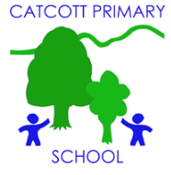Catcott Primary School Medium Term Planning Year 6 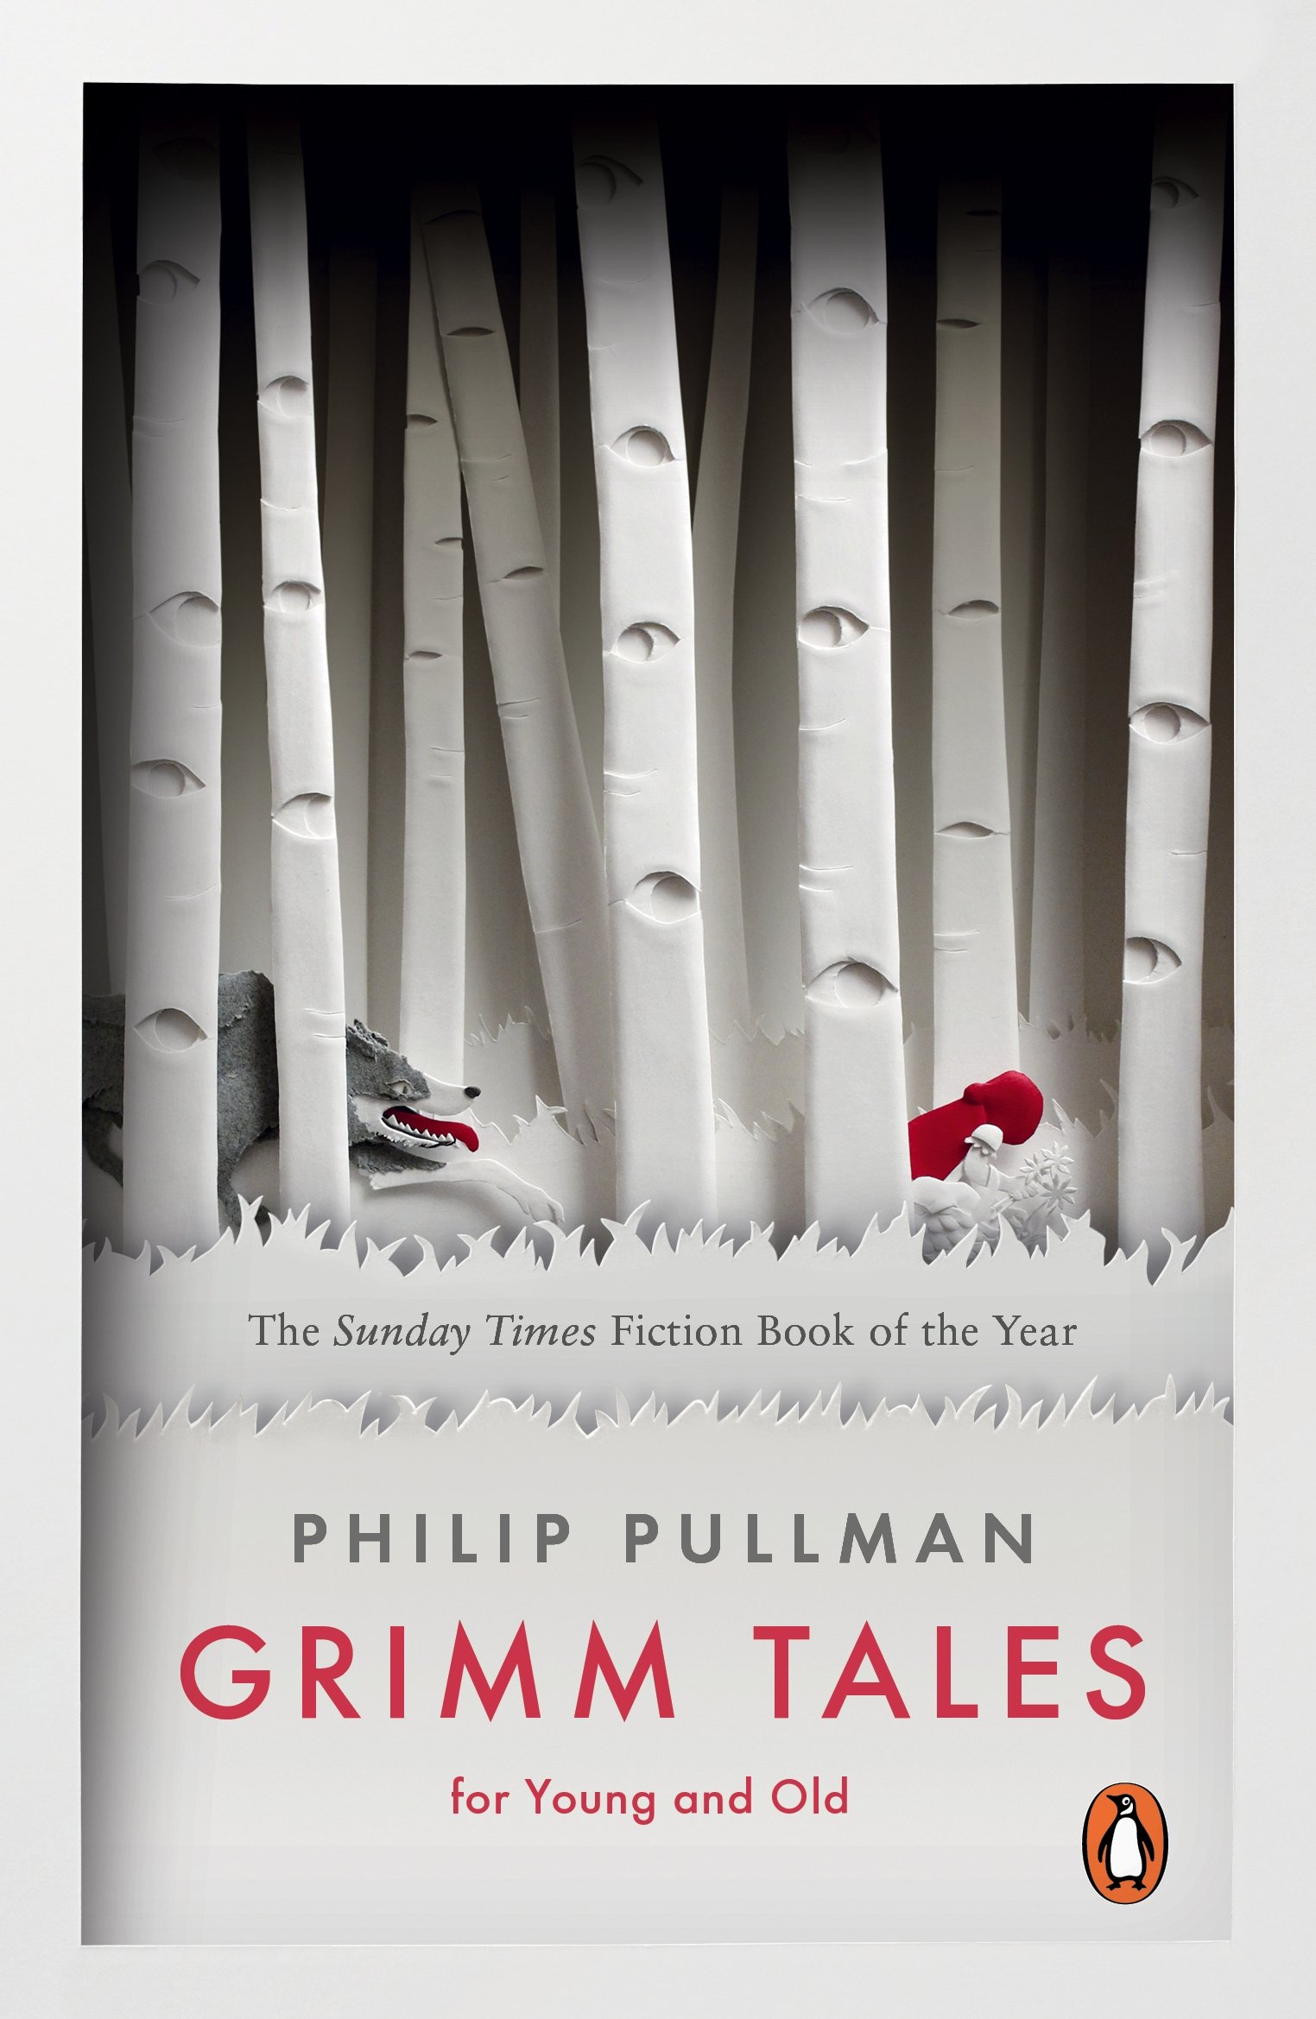

Quality Text(s) | Grimm Tales; Twisted Fairy Tales
Launch | Children come into the classroom to find the following on the whiteboard with a drop of blood below: Talking partners: Discuss: What kind of stories do you know that follow this word? Why is there a drop of blood? What kind of characters appear in stories like this? Do they all have fairies in them? Do they all have happy endings?  Have a bag ready containing a range of props, for example: a toy sword, a cloak, scraps of fur, a feather, a ruffled cap, a toy mouse, a rose, a lump of coal, a gold braid, a small mirror etc. Invite children to come and select an item from the bag, then question and hypothesize using modals: I wonder who/where/what…? Could it be…? Might they have…? Tell children that fairy tales have been retold - often orally - over many years. In pairs, challenge children to choose a selection of three items from the bag to create an impromptu fairytale - this may only be a few sentences long.
Pre-assessment writing task | Cold task: read The Frog Prince, re-write from the frog's perspective
Model Text | - https://grammarsaurus.co.uk/portal/2022/12/year-6-model-text-narrative-the-frog-princess-%f0%9f%8f%b4%f3%a0%81%a7%f3%a0%81%a2%f3%a0%81%b3%f3%a0%81%a3%f3%a0%81%b4%f3%a0%81%bf-p6-%f0%9f%87%a6%f0%9f%87%ba%f0%9f%87%ba/
Reading – comprehension and vocabulary focus | Increasing their familiarity with a wide range of books, including myths, legends and traditional stories, modern fiction, fiction from our literary heritage, and books from other cultures and traditions • Identifying and discussing themes and conventions in and across a wide range of writing • Drawing inferences such as inferring characters’ feelings, thoughts and motives from their actions, and justifying inferences with evidence • Participate in discussions about books that are read to them and those they can read for themselves, building on their own and others’ ideas and challenging views courteously
Key text type features | rhetorical questions, adverbials of place, adverbials of time, short sentences for eect, expanded noun phrases, adverbials of manner (including similes), co-ordinating conjunctions, participial phrases, participial adjectives, expanded noun phrases, adverbials of place, hyphenated words, adverbials of manner (including similes), co-ordinating conjunctions, subordinating conjunctions, short sentences for effect, rhetorical questions, relative clauses, rhetorical questions ellipses. modal verbs, participial phrases
Focus grammar and punctuation objectives | • Indicating degrees of possibility using adverbs [for example, perhaps, surely] or modal verbs [for example, might, should, will, must] • The difference between structures typical of informal speech and structures appropriate for formal speech and writing [for example, the use of question tags: He’s your friend, isn’t he?, or the use of subjunctive forms such as If I were or Were they to come in some very formal writing and speech] • Linking ideas across paragraphs using a wider range of cohesive devices: repetition of a word or phrase, grammatical connections [for example, the use of adverbials such as on the other hand, in contrast, or as a consequence], and ellipsis
Writing task(s)  Individual?  Pair?  Group? | Share write Cinderella from the Ugly Stepsister’s perspective (de:de sentence focus),  · Share write Cinderella from the Stepmother’s perspective (active and passive verb form focus),  · Share write Cinderella from the Prince’s perspective (punctuating speech focus)  Hot task: write Little Red Riding Hood from the wolf's perspective, greater depth to create and write their own fairy tale from a villain's perspective.

