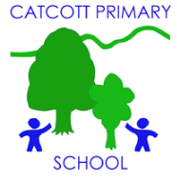Catcott Primary School Medium Term Planning Year 6 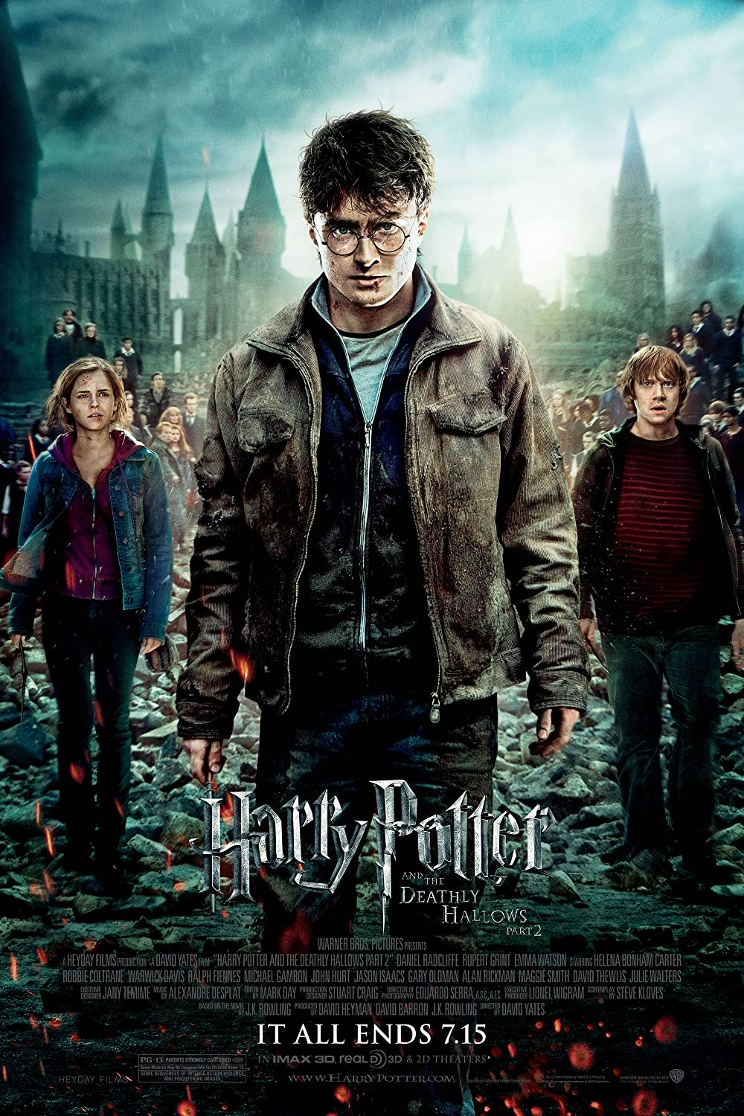

Quality Text(s) | Harry Potter; Flashbacks
Launch | In classroom, create Harry Potter display- platform 9 3/4 etc.  Show chn a list of films that contain flashbacks that chn may have seen. Watch clips from film list, chn should discuss what techniques are used to show the viewer (or reader) that the character is having a flashback – wavy lines, black & white images, soft focus, use of particular vocabulary, referring to a dream, etc. Which characters have the flashbacks? Chn may also be able to suggest other books or films that include flashbacks – they should list any they know.
Pre-assessment writing task | Cold task: Literacy Shed- The Piano
Model Text | https://grammarsaurus.co.uk/portal/2020/01/year-6-model-text-a-veteran-never-forgets-flashback/  Extracts from the Harry Potter books:  - Flashback using dreams, Order of the Phoenix.  - Flashback using memories, The Philospher’s Stone.  - Flashback using the Pensieve, Half Blood Prince.
Reading – comprehension and vocabulary focus
Key text type features | Imagery and figurative language  Narratives and retellings are written in the first or third person • Narratives and retellings are written in past tense, occasionally these are told in the present tense • Narratives are told sequentially and non-sequentially (eg. flashbacks) through the use of adverbials and prepositions • Descriptions, of characters, setting and atmosphere are developed through precise vocabulary choices eg. adverbs, adjectives, precise nouns, expressive verbs and figurative language • Dialogue is used to convey characters’ thoughts and to move the narrative forward, Common Structure: - an opening that establishes setting and introduces the characters; - a complication and resulting events; - a resolution/ending
Focus grammar and punctuation objectives | Grammar: rhetorical questions, adverbials of place, adverbials of time, short sentences for e­ect, expanded noun phrases, adverbials of manner (including similes), co-ordinating conjunctions, participial phrases, participial adjectives, expanded noun phrases, adverbials of place, hyphenated words, adverbials of manner (including similes), co-ordinating conjunctions, subordinating conjunctions, short sentences for effect, rhetorical questions, relative clauses, rhetorical questions ellipses. modal verbs, participial phrases  Punctuation: ellipses
Writing task(s)  Individual?  Pair?  Group? | · Share write a flashback using dreams (tell: show 3 examples; sentences focus),  · Share write a flashback using memories (punctuating speech focus),  Share write flashback using ‘the pensieve’ (emotion-consequence sentence focus),  Hot task: Re-write Professor Slughorn horcrux flashback

