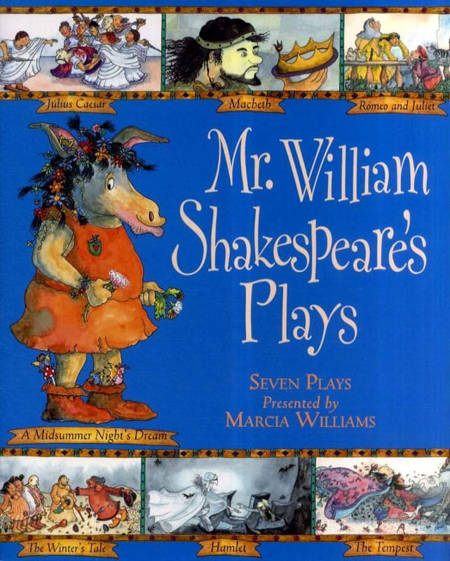
Catcott Primary School Medium Term Planning Year 6

Quality Text(s) | Shakespeare by Marcia Williams
Launch | Shakespeare week resources https://www.teachwire.net/news/shakespeare-week-primary-resources/
Pre-assessment writing task | Cold task: Write a biography of Louis Sacha
Model Text | GD- https://grammarsaurus.co.uk/portal/2017/06/new-year-6-greater-depth-model-text-charles-darwin-biography/
Reading – comprehension and vocabulary focus
Focus grammar and punctuation objectives | Grammar: adverbials of time, passive voice (Y6), subordinating conjunctions, relative clauses, passive voice (Y6), expanded noun phrases, present perfect tense, subheadings, subjunctive mood/form (Y6), parentheses, apostrophes for possession, passive voice (Y6), conjunctive adverbs, adverbials of time, perfect tense  Punctuation: colons (Y6), parentheses, apostrophes for possession, commas for lists
Writing task(s)  Individual?  Pair?  Group? | Share write: To write William Shakespeare’s biography  Hot task: Write a biography of a chosen famous person

