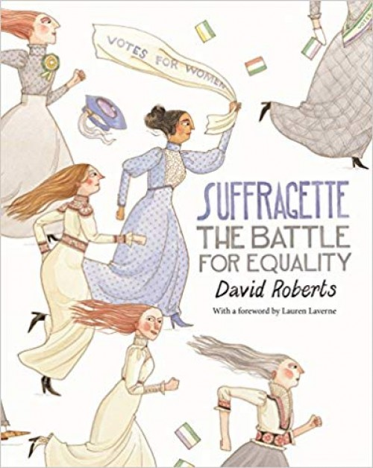
Catcott Primary School Medium Term Planning Year 6

Quality Text(s) | Suffragette The Battle for Equality
Launch | Divide and Rule! Without introducing the book, divide the children up into boys and girls and tell the boys they are part of a new school council. Ask them to write down ten new laws that they think should be adopted which would favour the boys above the girls. Meanwhile ask the girls if they think this is fair. Ask them if they can write a headline to say why it’s unfair to sum up the situation. Give them a roll of paper (a banner!) to display this on.
Pre-assessment writing task | Cold task: Non chronological report about Shepton Prison
Model Text | https://grammarsaurus.co.uk/portal/2023/07/year-6-model-text-non-chronological-report-the-strangest-trials-in-history-%f0%9f%8f%b4%f3%a0%81%a7%f3%a0%81%a2%f3%a0%81%b3%f3%a0%81%a3%f3%a0%81%b4%f3%a0%81%bf-p6-%f0%9f%87%a6/
Reading – comprehension and vocabulary focus | Continuing to read and discuss an increasingly wide range of fiction, poetry, plays, non-fiction and reference books or textbooks • Increasing their familiarity with a wide range of books, including myths, legends and traditional stories, modern fiction, fiction from our literary heritage, and books from other cultures and traditions • Identifying and discussing themes and conventions in and across a wide range of writing • Checking that the book makes sense to them, discussing their understanding and exploring the meaning of words in context • Drawing inferences such as inferring characters’ feelings, thoughts and motives from their actions, and justifying inferences with evidence • Participating in discussions about books that are read to them and those they can read for themselves, building on their own and others’ ideas and challenging views courteously • Providing reasoned justifications for their views
Focus grammar and punctuation objectives | Grammar: subordinating conjunctions, adverbials of time, relative clauses, adverbials of place, passive voice (Y6), present perfect tense, expanded noun phrases, rhetorical questions, subjunctive mood/form (Y6) tense switch (if applicable)  Punctuation: parenthesis, colons (Y6), apostrophes for possession
Writing task(s)  Individual?  Pair?  Group? | Share write: Non chronological report about The Suffragette Movement  Hot task: How has Crime and Punishment Changed?

